Summer Assignment

AP Environmental Science
Dear Future APES ________________________________________________,
Congratulations on your decision to take AP Environmental Science this upcoming school year. I would like you to spend some time thinking about the environment; when you are outside, watching T.V., reading a magazine, newspaper, or even on vacation.
- PHOTO ACRONYM COLLAGE: Environmental Science Expectations
You are creating an acronym of your name, which includes an environmental concept for each letter of your name. We will be presenting these on the first day of class, and it will be your first grade of the nine weeks.
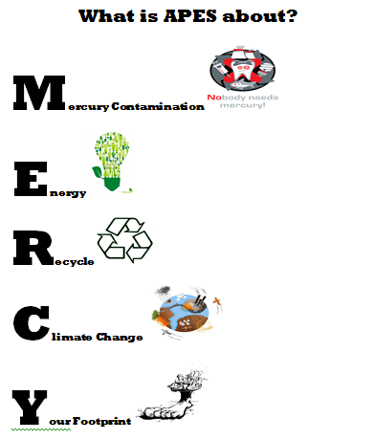
- MATH PRACTICE: Introduction to Environmental Science

This year in APES you will hear the two words most dreaded by high school students…NO CALCULATORS! That’s right, you cannot use a calculator on the AP Environmental Science exam. Since the regular tests you will take are meant to help prepare you for the APES exam, you will not be able to use calculators on regular tests all year either. The good news is that most calculations on the tests and exams are written to be fairly easy calculations and to come out in whole numbers or to only one or two decimal places. The challenge is in setting up the problems correctly and knowing enough basic math to solve the problems. With practice, you will be a math expert by the time the exam rolls around. So bid your calculator a fond farewell, tuck it away so you won’t be tempted, and start sharpening your math skills!
Please make sure to visit the class website so that you may become familiar with the class dynamics and my expectations. http://smsh.dadeschools.net/science/aycart/apes/apes.htm
If you have questions regarding the course or summer assignment, I can be reached at merodriguez@dadeschools.net.
See you next year.
Mercy Aycart

Mercy Aycart
Science Department Chairperson
APES Teacher

